**UNVEILING MARKET INSIGHTS ANALYING SPENDING BEHAVIOUR**

**INTRODUCTION:**

Analysing spending behaviour is a crucial endeavour for business and researches seeking

to unveil valuable market insights. By scrutinizing consumer habits and financial choices, one can gain a deeper understanding of purchasing patterns, preferences, and trends. This data-driven approach empowers business to make informed decisions.

**EMPATHY MAP**

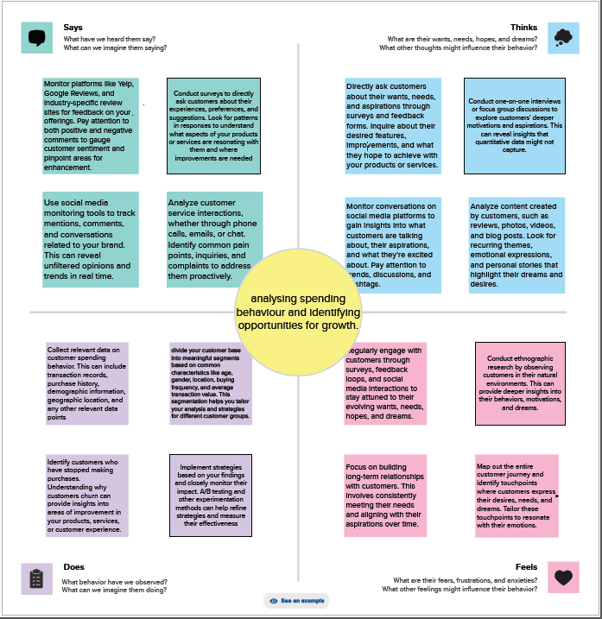

**BRAINSTORM**

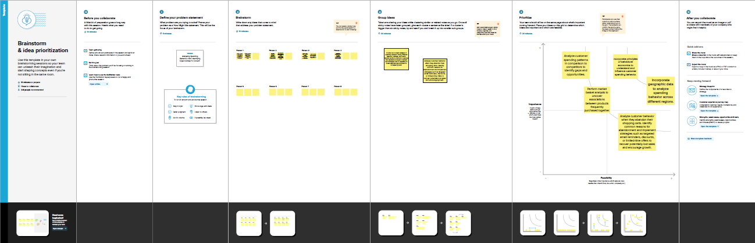

**ARROW CHART**

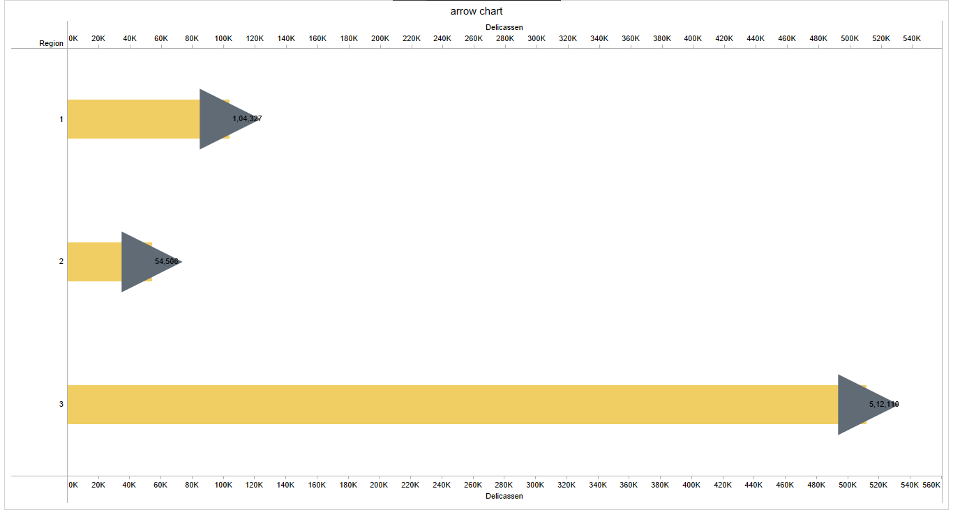

**BAR AND AREA CHART**

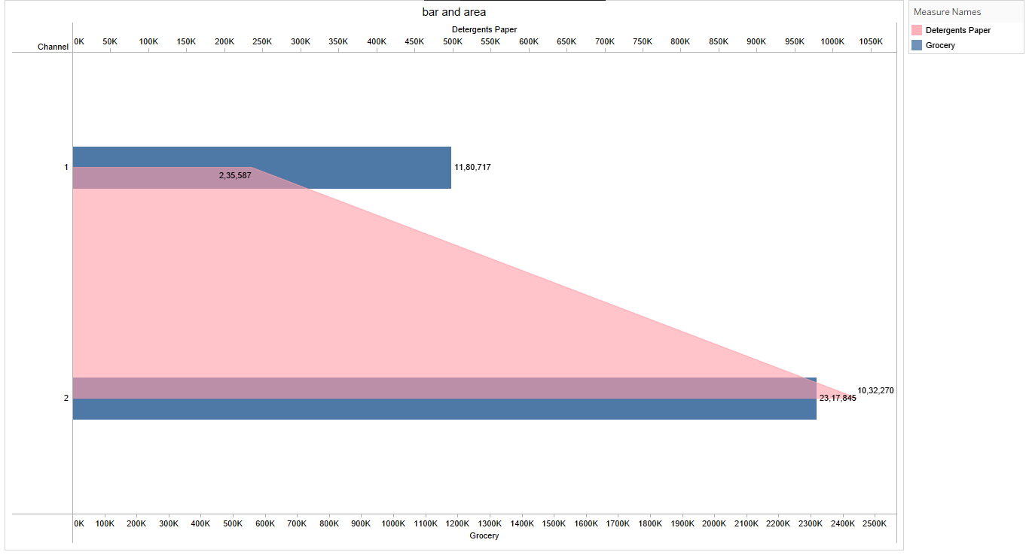

**BUTTERFLY CHART**

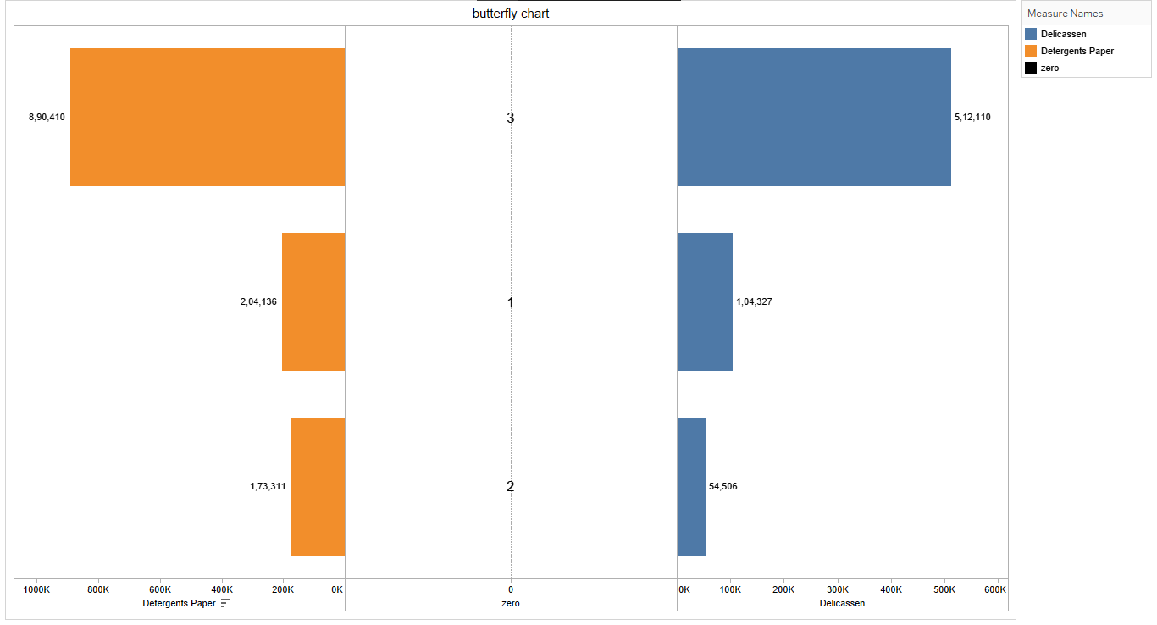

**LOLLIPOP CHART**

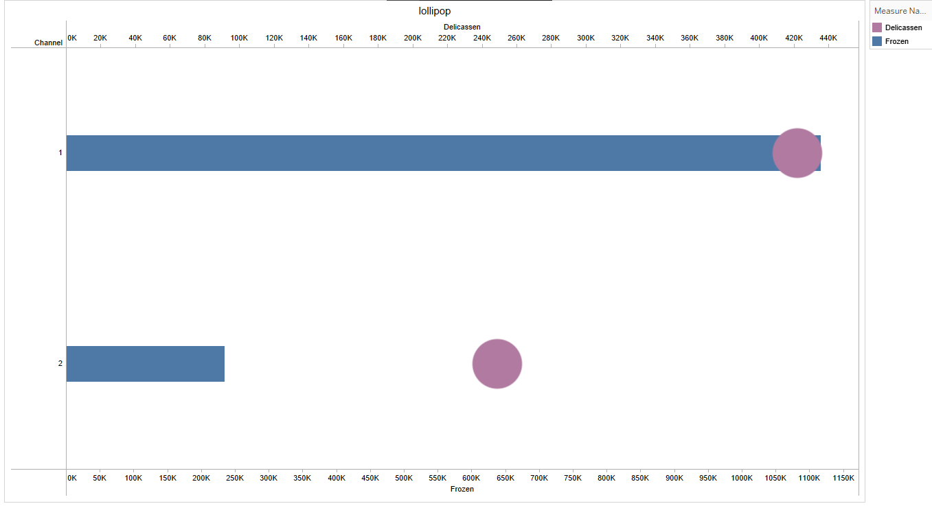

**PIE CHART**

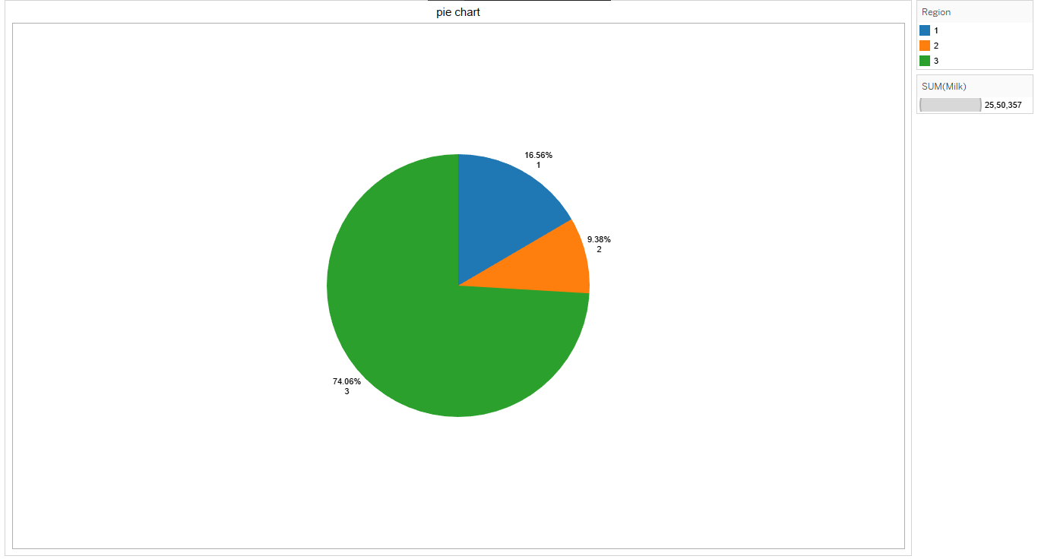

**POLYGEN CHART**

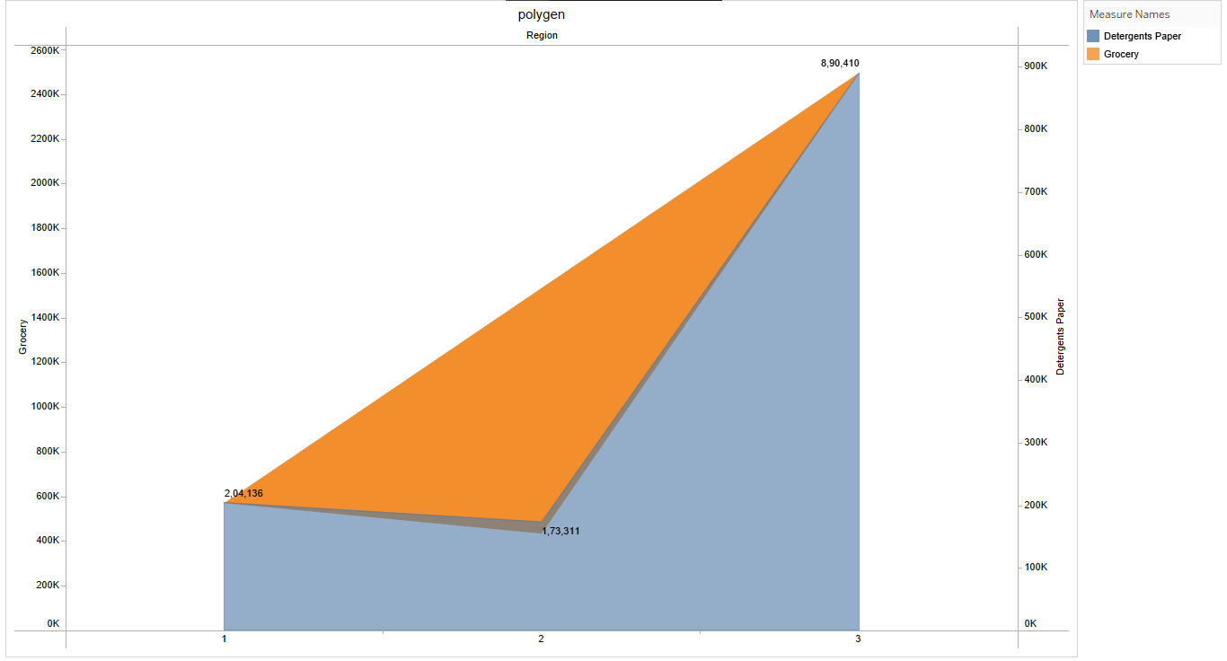

**DASHBOARD**

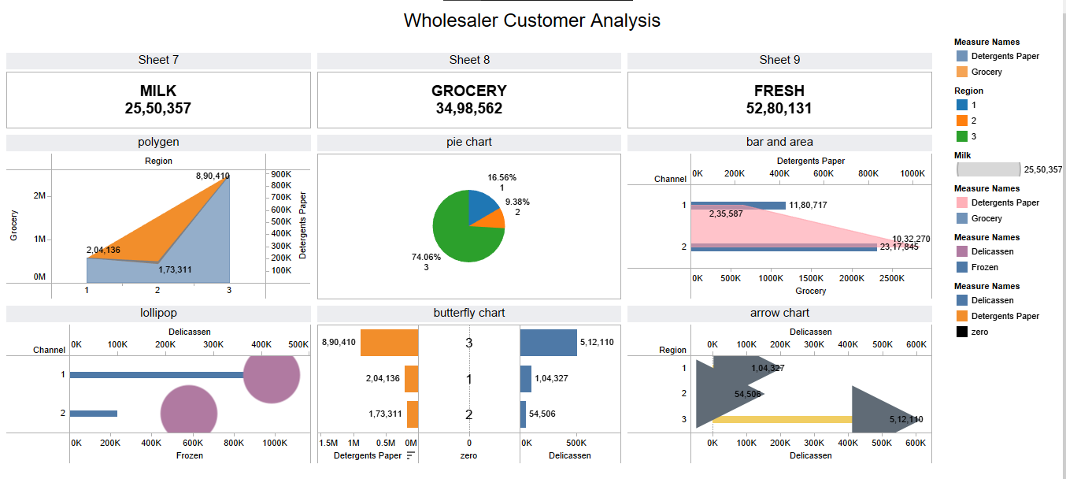

**STORY**

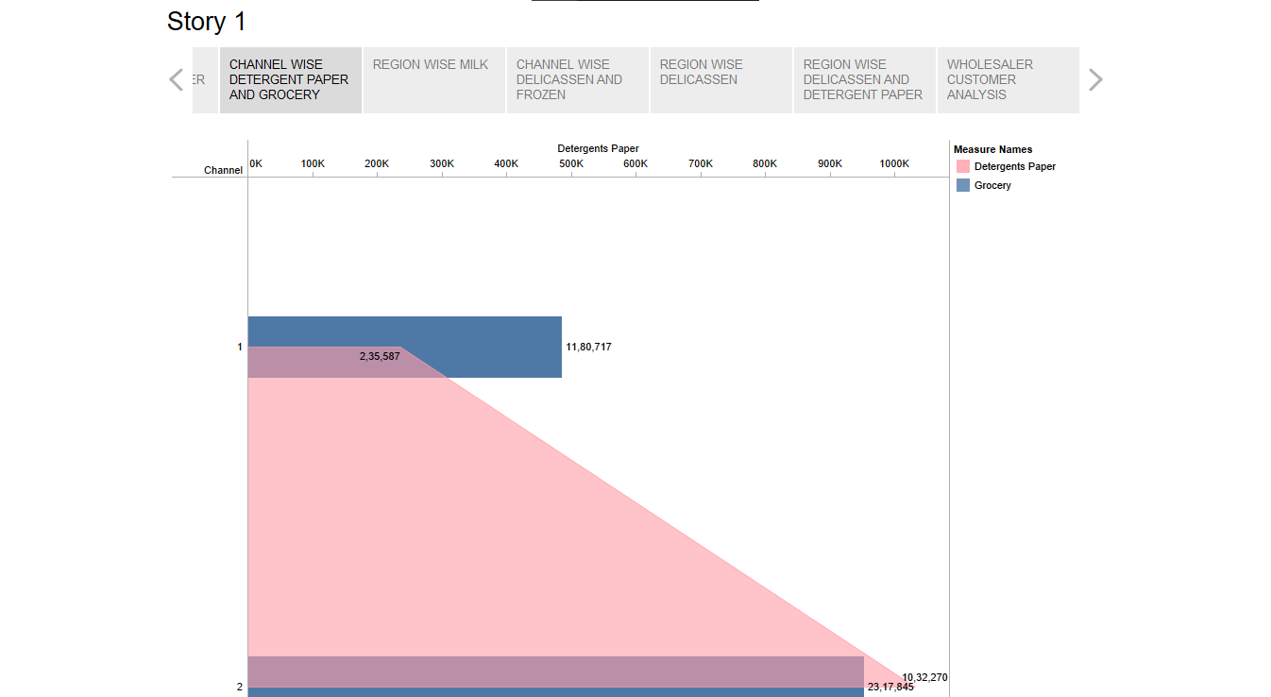

**CONCLUSION**

Analyzing spending behavior to unveil market insights can be valuable strategy for business. By understanding how

consumers allocate their resources, companies can make informed decisions about product development, pricing, and marketing. This data-driven approach can lead to increased profitability, customer satisfaction, and a competitive edge in the market. However, it’s essential to use ethical and privacy-conclusions methods when collecting and analyzing consumer spending consumer data to maintain trust and compliance with regulations.